Please utilize the following justification letter templates to appeal for funding from employers, CDC, and other entities that would aid and support you in attending the ASHA conference. Choose the template that best fits your needs and tailor it to your specific requests.

Template 1: In-Person Conference
[MONTH DAY], 2024

Dear [YOUR SUPERVISOR’S NAME]:

More than ever, keeping current in the field of school health is essential to our students, school staff, and our community. The American School Health Association (ASHA) is hosting its annual conference on October 16-18, 2024, in Pittsburgh, Pennsylvania. The conference focuses on a coordinated school health approach to enhance student wellness and learning. I am requesting permission to attend this conference and hope that the [SCHOOL/DISTRICT/AGENCY/UNIVERSITY] will assist with the costs of my attendance, which are outlined below.

ASHA’s School Health Conference will enable me to network with other school health professionals and engage in deep learning facilitated by experts in the field. The sessions are directly applicable to my work. They will provide me with skills and resources for planning and implementation of collaborative approaches. In-person participation will also enable me to build a professional network with school health experts from around the country and the world. These contacts will help our team develop more efficient and effective programs to improve the health and academic achievement of all students. I will gladly share all information with others at [SCHOOL/DISTRICT/AGENCY/UNIVERSITY PERSONNEL].

I will also earn continuing education units as required for professional licensure and certification. Furthermore, the conference registration includes registration for the virtual conference and covers meals, saving on food costs.

The total cost to attend the in-person ASHA Conference is [INSERT TOTAL COST], which includes:
- Conference Registration: $225 ($225 is the regular member rate-- see table on last page for fees for retired members, students, & non-members)
- Lodging: [INSERT COST as per night plus tax]
- Airfare: [INSERT ESTIMATED FARE TO/FROM YOUR CITY]
- Ground Transportation: [INSERT COST of transportation to airport, parking, and transportation to hotel]

I appreciate your support and hope you approve my attendance at this important conference.

Sincerely,

[YOUR NAME AND TITLE]

Template 2: Virtual Conference
[MONTH DAY], 2024

Dear [YOUR SUPERVISOR’S NAME]:

More than ever, keeping current in the field of school health is important to our students, school staff, and our community. The American School Health Association (ASHA) is hosting a virtual conference on [DATE]. The conference focuses on a coordinated school health approach to enhance student wellness and learning. I am requesting permission to attend this conference and hope that the [SCHOOL/DISTRICT/AGENCY/UNIVERSITY] will assist with the registration cost of $275 ($275 is the non-member rate--see table on last page for fees for regular members, retired members, & students). Registration also includes a one-year ASHA membership, providing me with additional opportunities to learn and network within the school health field.

ASHA’s School Health Conference will enable me to learn from experts in the field and gather resources for the planning and implementation of collaborative approaches. This will help our team develop more efficient and effective programs to improve the health and academic achievement of all students. I will gladly share all information with others at [SCHOOL/DISTRICT/AGENCY/UNIVERSITY PERSONNEL].

Furthermore, I will have the opportunity to earn continuing education units as required for professional licensure and certification.

I appreciate your support and hope you approve my attendance at this important conference.

Sincerely,

[YOUR NAME AND TITLE]

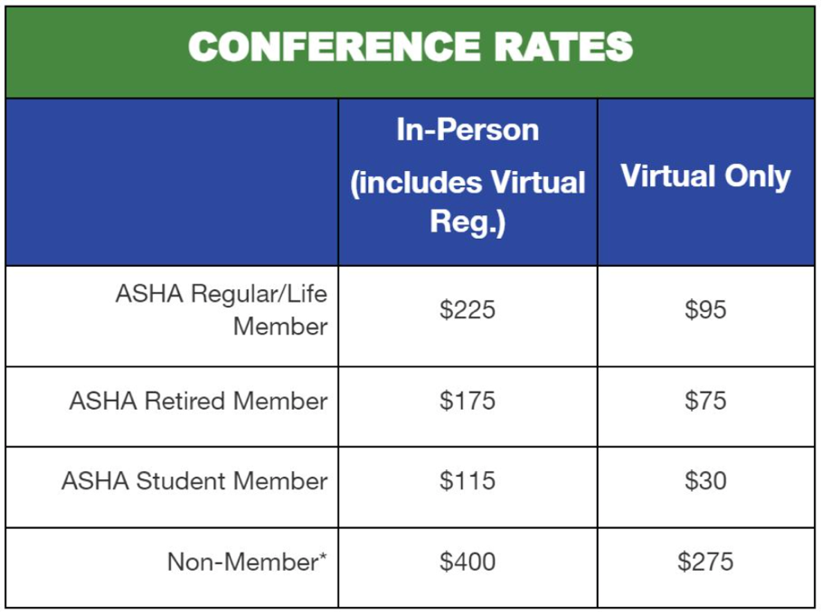

*The in-person fee also includes registration to the virtual conference
*Non-member registration includes an ASHA membership

